## Abstract

Recommender systems are algorithms aimed at suggesting relevant items to users (items being movies to watch, text to read, products to buy or anything else depending on industries). Here we built to recommend and predict anime for users. explore the contents of this dataset to gain insights by

* Analysis
* Evaluation

The goal of this project is to recommend and make predictions about a user’s taste of what a user will want to watch later.

## Design

* **Data Loading**
* **Data Exploring**
* **Data Cleaning**
* **Data visualization**
* **Data Preprocessing**
* **Data splitting**

## Data

**provided by Kaggle website**





<https://www.kaggle.com/CooperUnion/anime-recommendations-database?select=rating.csv>

## Algorithms

**Collaborative Filtering**

**Content-Based Filtering**

**KNN Model**

**Principal Component Analysis (PCA)**

**Cluster: K-means**

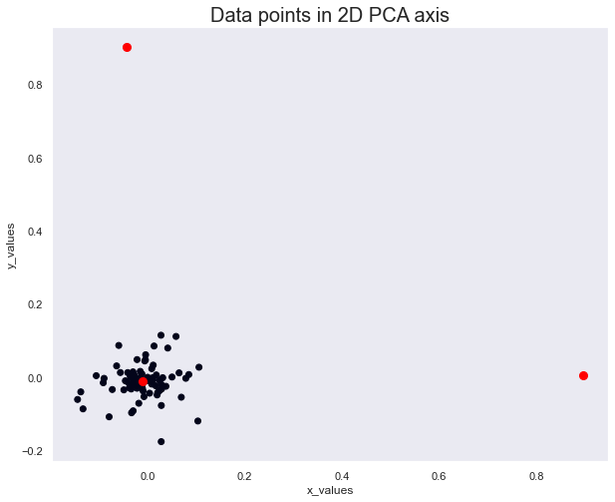

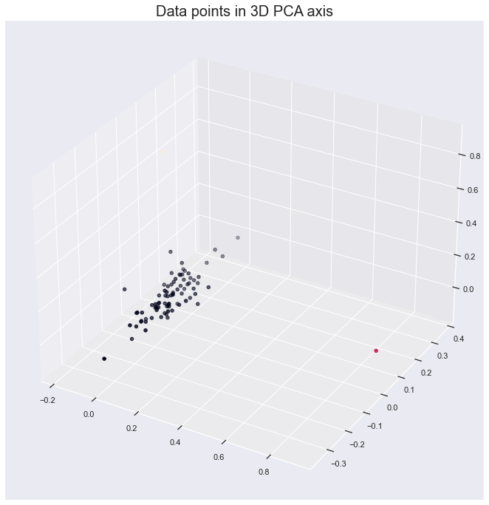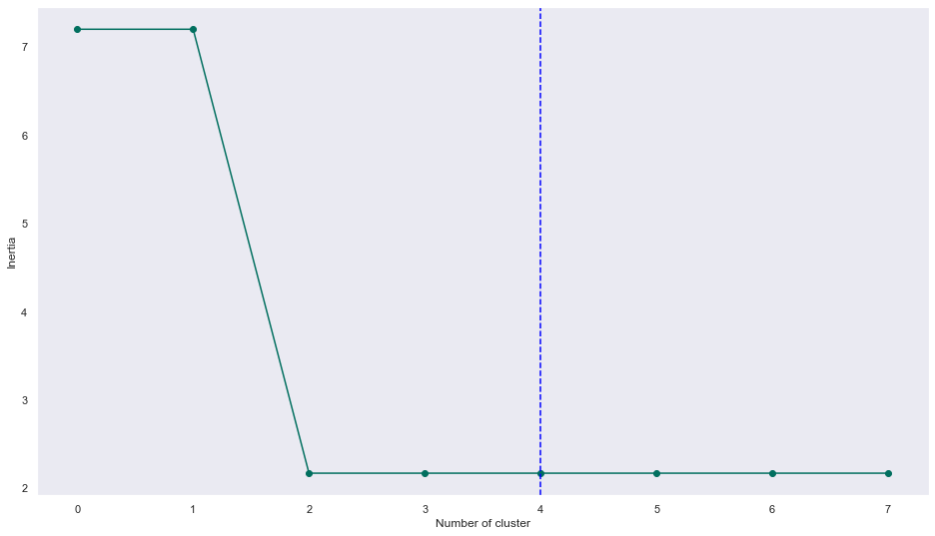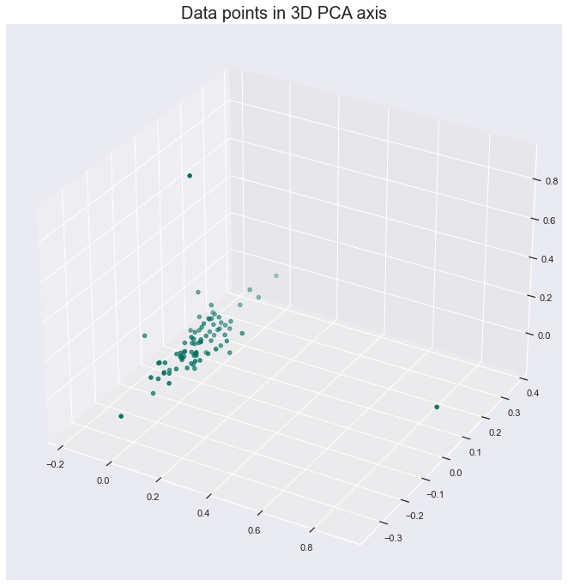

## Tools

* **Numpy and Pandas for data manipulation**
* **Scikit-learn for modeling**
* **Matplotlib and Seaborn for plotting**
* **Tableau for interactive visualizations**